Transgender Resource Guide

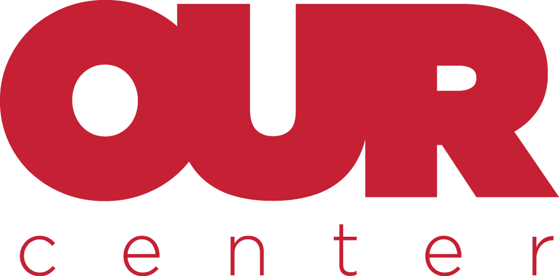

  - Updated: 7/31/24

General Healthcare Resources in Reno, NV

Northern Nevada HOPES
580 West 5th Street
Reno, NV 89503
(7750 786-4673

Regular hours of operation: Monday – Friday 8am - 5pm
Extended Hours on Monday and Thursday from 5pm – 7pm

Website: www.nnhopes.org
www.nnhopes.org/programs/gender-sexual-healthcare-clinic/

At HOPES we welcome all members of the Lesbian, Gay, Bisexual, Transgender, and Queer community. We support the LGBTQ+ community by providing culturally competent healthcare, social services, and community outreach education. Together, we can create a strong, cohesive LGBTQ+ network that connects people, solves problems, and builds a healthier Reno community.

Need to be a patient of HOPES to access these services/resources, this can be done by calling (775) 786-4673 to become a HOPES patient.
www.nnhopes.org/patients/become-a-patient/
Alternatively, you can also email Sydnie, the Gender Affirming Care Coordinator for HOPES or Griselda Becerra, the Director of Patient Services for assistance in becoming a patient.
Sydnie: swalters@nnhopes.org
Griselda Becerra: gbecerra@nnhopes.org

Available Resources at HOPES:
Hormone Replacement Therapy (HRT)
Onsite pharmacy where patients can receive their HRT medications
Case management
Financial Support
Gender affirmation and processing therapy group
Gender affirming surgery mental health evaluation letter

Planned Parenthood
8025 South Virginia Street
Reno, NV 89511
(775) 688-5555

Normal Hours of Operation: Monday – Friday 8:30am – 5pm

Websites/Links:
Planned Parenthood Gender Affirming Care: www.plannedparenthood.org/planned-parenthood-mar-monte/patient-resources/gender-affirming-care
Reno Location and booking an appointment: www.plannedparenthood.org/health-center/nevada/reno/89511/reno-health-center-2262-90130/gender-affirming-care

Available Resources at Planned Parenthood:
Gender affirming surgery referrals
Gender affirming hormone therapy
Start or continue HRT and provide referrals for gender-qualified therapy and resources if needed. If currently on HRT, you can utilize the health center for ongoing care and monitoring.

Renown Health
LGBTQ+ Care at Renown

75 Pringle Way, Suite 505
Reno, NV 89502

Hours:
8am-4:30pm (M-F)
Closed for Lunch 12pm-1pm

Outside Lines:
(775) 982-KIDS (5437)

Caroline Barangan (listed below and Kathryn Eckert are the “featured” physicians. Kathryn Eckert no longer works in Reno.)

All patients may be seen with an On Demand Video Visit or in the office.

Trans Voice & Communication Clinic
The trans Voice and Communication Clinic is Operated at the UNR School of Medicine in partnership with the Department of Speech Pathology & Audiology

Nell J. Redfield Building
Reno, NV 89557-0152

Contact: Rachael Walden
rwalden@med.unr.edu
Clinic Phone: (775) 982-3300

The trans voice and communication clinic provides assessments and individualized treatment programs to all ages for the purpose of voice modification and communication skills to better match gender identity. The University of Nevada, Reno Speech and Hearing Center and its clinics are a Safe Zone. Clinicians and supervisors are LGBTQIA+ friendly.

They are not currently holding group sessions due to a lack of faculty, but they are still accepting patients. You need a referral from your medical provider to be a patient, and this can be sent through the Epic system or faxed to (775) 982-8042. All clinical operations are through renown which means insurance and other billing matters happen through the Renown system.

For questions you can email Rachael Walden who is a faculty member at the UNR School of Medicine and oversees the clinic. Her email is rwalden@med.unr.edu.
You can also call the clinic directly at (775) 982-3300, and ask for the Trans Voice & Communication Clinic.

Website (although it is a bit outdated):
med.unr.edu/speech-pathology/clinics/trans

Gender Affirming Surgery in Reno, NV

Talbott Plastic Surgery Center
5060 Meadowood Mall Circle Suite 200
Reno, NV 89502
(775) 348-4790

Dr. LaDawn Talbott
Plastic Surgeon
Instagram Handle: @dr.talbott
Website: https://www.talbottmd.com

Gender Affirming Physicians & Pediatricians

Karen Thiele
Community and Family Medicine Dr.
kthiele@med.unr.edu

745 W. Moana Ln
Reno, NV 89509
(775) 982-1000 (Renown Practice #)

Bio Page on UNR: https://med.unr.edu/people/karen-thiele

Dr. Thiele is an Assistant Professor at the Department of Family and Community Medicine. She completed her residency in Family and Community Medicine from the University of Nevada, Reno, in 2019. She enjoys the broad scope of practice of a family doctor and has patients that encompass all ages and stages of life, including obstetrics. Her special interests include primary care of the LGBT+ community, providing cross-gender hormone therapy for gender-diverse patients, women's reproductive health, PrEP, and wilderness medicine.

Caroline Barangan
Adolescent Medicine

(775) 982-5437
Renown Children’s Pediatric Specialty Care
https://www.renown.org/find-a-doctor/caroline-barangan

Anamarie Manea
Pediatric Endocrinologist

(775) 982-5437
Renown Children’s Pediatric Specialty Care
https://www.renown.org/find-a-doctor/anamaria-manea

Sherrie Hald
OBGYN

OBGYN Associates
(775) 329-6241
635 Innovation Dr. Suite 300
Reno, NV 89511
https://www.obgynreno.com/team/sherrie-hald/

Nevada Gender Clinic
Online Gender Affirming Provider and Resource Guide

https://www.nvgenderclinic.com/contact

Referral, Evaluation, Treatment & Mental Health

Mary Minten
Dr. Mary Minten is a Licensed Marriage and Family Therapist and AASECT Board Certified Sex Therapist. Specializing in relational, sexual, and emotional health.

(775) 329-4582
1005 Forest St.
Reno, NV 89509
http://www.marymintencounseling.com

Dr. Tory Clark
Tory Clark is a licensed Marriage and Family Therapist with a broad ranging background in health and human services.

467 Ralston St.
Reno, NV 89509
(775) 843-9593
https://transgenderheaven.com/places/dr-tory-clark-dhs-cadc-i-mft-i/

Elizabeth Dear
Marriage and Family Therapist

527 Plumas St.
Reno, NV 89509
(775) 348-4696
https://beyondcbt.com

Jacqueline Kleinedler
Marriage and Family Therapist

1005 Forest St.
Reno, NV 89509
(775) 329-4582

Paul Kwon, Ph.D - The Pride Center (University of Nevada, Reno)
Department of Psychology, LGBTQIA+ Clinical Services
The PRIDE Center
(775) 784-6668
pkwon@unr.edu
https://www.unr.edu/psychological-services-center/services

Bernadette Hinojos
Psychological Associate, PsyD

5595 Kietzke Lane
Suite 110
Reno, NV 89511
(775) 254-8621
https://www.psychologytoday.com/us/therapists/bernadette-hinojos-reno-nv/447725
You are able to email from the above link as well. See the right side of screen with a button labeled “email me.”

Dr. Luke R. Allen
Licensed Psychologist
Online Therapy/Appointments Only

Business Mailing Address
1050 E. Flamingo Rd S107 1456
Las Vegas, NV 89119
(702) 530-6134
https://lukeallenphd.com/contact-me

Legal Services

Nevada Legal Services
Free legal services for low income Nevadans

449 S. Virginia St.
3rd Floor
Reno, NV 89501
(775) 284-3497
Email: renointake@nevadalegalservices.org

https://nevadalegalservices.org
https://nevadalegalservices.org/contact/
Reno office is closed for lunch Monday-Thursday 12-12:30
The Reno office accepts Walk-Ins Monday-Thursday 8am-3:30pm. Friday’s are by appointment only.

Fill out the intake form in order to expedite support: https://nlsoi.legalserver.org/modules/matter/extern_intake.php?pid=129&h=daa817&

Other Services

Carleen Sanchez
Trans Affirming Hair Stylist
Specializing in Curly Hair, but available to all

Text: (775) 721-2969
carleenrocks@yahoo.com
https://haircutcolor.com

Outsiders Hair Studio
All Inclusive Reno Hair Salon and Community
18B Winter Street
Reno, NV 89503

(775) 323-1548
https://outsidershair.com

Tattoo Artists (upcoming/ongoing)

Services Outside of Reno, NV

UCSF Center of Excellence in Trans Health
Increasing access to comprehensive, effective, and affirming healthcare services for transgender communities
https://prevention.ucsf.edu/transhealth

National Center for Transgender Equality
The National Center for Transgender Equality advocates to change policies and society to increase understanding and acceptance of transgender people. In the nation’s capital and throughout the country, NCTE works to replace disrespect, discrimination, and violence with empathy, opportunity, and justice.
https://transequality.org/

Trans Lifeline
Trans lifeline is a grassroots hotline and microgrants 501(c)(3) non-profit organization offering direct emotional and financial support to trans people in crisis - for the trans community, by the trans community.
https://translifeline.org

Reno Family Physicians (Group)
Has yet to hear back from them in any capacity. A physician who retired from their practice used to be on an old resource guide providing HRT.

